**EMPLOYEE PERFORMANCE DASHBOARD**

**ABSTRACT**

The project aims to develop an Employee Performance Dashboard to visually represent various performance metrics of employees across different departments. The dashboard consolidates data regarding performance scores, project completion rates, and training durations. It facilitates the analysis of performance rating by department, job title, educational qualification, and gender. The visualization tools and methodologies used in the project ensure clear and actionable insights for management. The project implements data visualization techniques using Tableau. Overall, the Employee Performance Dashboard project demonstrates the value of data visualization in organizational performance management, providing a comprehensive tool for monitoring and improving employee performance across various dimensions.

**TABLE OF CONTENTS**

|  |  |  |
| --- | --- | --- |
| **CHAPTER NO.** | **TITLE** | **PAGE NO.** |
|  | **ABSTRACT** | I |
|  | **TABLE OF CONTENTS** | II |
|  | **LIST OF FIGURES** | III |
|  | **LIST OF ABBREVIATIONS** | IV |
| **1** | **INTRODUCTION** | 1 |
|  | 1.1 Problem Statement | 1 |
|  | 1.2 Scope of the Project  1.3 Objectives of the Project  1.4 Applications | 1  2  2 |
| **2** | **SYSTEM DESIGN AND IMPLEMENTATION** | **3** |
|  | 2.1 Design Methodology | 3 |
|  | 2.2 Implementation Details | 3 |
| **3** | **RESULTS AND DISCUSSIONS** | 4 |
| **4** | **CONCLUSION** | 15 |
|  | **REFERENCES** | **16** |

**LIST OF FIGURES**

|  |  |  |
| --- | --- | --- |
| **FIGURE NO** | **TITLE** | **PAGE** |
| 1.1 | Dashboard Overview | 4 |
| 1.2 | Interactive dashboard by Department Filter | 6 |
| 1.3 | Interactive dashboard by Performance Score Filter | 7 |
| 1.4 | Interactive Dashboard using Filters | 8 |

**LIST OF ABBREVIATIONS**

KPI’s - Key Performance Indicators

**CHAPTER 1**

**INTRODUCTION**

The Employee Performance Dashboard project is situated within the broader context of performance management systems. It aims to provide a visual representation of employee performance metrics, allowing managers to easily identify top performers and areas needing improvement. The dashboard consolidates various performance-related data points into an interactive interface, making it easier for decision-makers to analyze and interpret the data.

**1.1 Problem Statement:**

Many organizations struggle with effectively managing and visualizing employee performance data. Traditional performance reviews often rely on subjective assessments and fail to provide a comprehensive view of an employee's contributions. Additionally, disparate data sources and lack of integration can hinder the ability to perform meaningful analysis and make data-driven decisions.

**1.2 Scope:**

The scope of this project includes the development of an Employee Performance Dashboard using Tableau. The dashboard will integrate performance data from multiple sources and provide visualizations such as bar charts, scatter plots, and heatmaps. It will allow users to filter data by department, job title, and other metrics, enabling a dynamic analysis of performance trends. The project also covers the implementation of key performance indicators (KPIs) to provide a quick overview of organizational performance.

**1.3 Objectives:**

1. To develop a comprehensive Employee Performance Dashboard that consolidates performance data from various sources.
2. To create visualizations that effectively communicate performance metrics and trends.
3. To enable interactive filtering and dynamic analysis of performance data.
4. To highlight key performance indicators such as average performance score, total projects completed, and training hours per employee.
5. To provide actionable insights that help managers identify top performers and areas for improvement.

**1.4 Applications:**

The Employee Performance Dashboard has several practical applications within an organization:

* **Performance Reviews:** Facilitates more objective and data-driven performance reviews by providing a comprehensive view of an employee's performance.
* **Talent Management:** Helps identify top performers for promotions and development opportunities.
* **Training Needs Analysis:** Highlights areas where additional training or support may be required.
* **Resource Allocation:** Assists in making informed decisions about resource allocation based on employee performance metrics.
* **Strategic Planning:** Supports strategic planning by providing insights into overall organizational performance and identifying trends.

**CHAPTER 2**

**SYSTEM DESIGN AND IMPLEMENTATION**

This chapter details the design and methodology used in developing the Employee Performance Dashboard. It includes the system architecture, module descriptions, and the algorithms implemented to process and visualize the data.

**2.1 Design Methodology:**

The design methodology involves the following steps:

* **Data Collection:** Gathering performance data from various sources.
* **Data Cleaning:** Ensuring the data is free from errors and inconsistencies.
* **Data Import:** Loading the cleaned data into Tableau for visualization.
* **Visualization Design:** Creating visual elements such as bar charts, scatter plots, and heatmaps.
* **Dashboard Integration:** Combining all visual elements into a cohesive dashboard.

**2.2 Implementation Details:**

* **Bar Charts:** Created to display performance scores by department, gender and individual employees.
* **Scatter Plots:** Used to analyze the correlation between performance scores and projects completed.
* **Heatmaps:** Developed to visualize the distribution of performance across different departments.

**CHAPTER 3**

**RESULTS AND DISCUSSIONS**

**3.1 Overview of the Dashboard:**

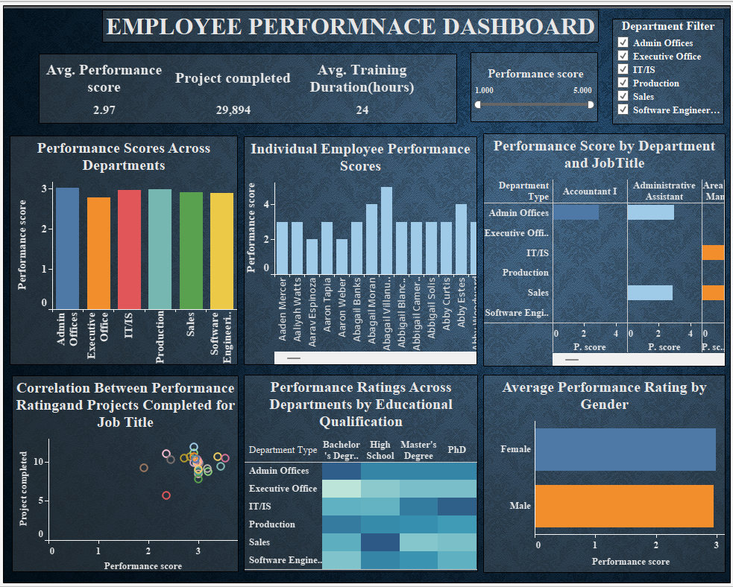

(figure 1.1) Dashboard Overview

The Employee Performance Dashboard is designed to provide an at-a-glance summary of key performance indicators (KPIs) and detailed performance metrics for individual employees and departments. The main components of the dashboard include:

1. **Key Performance Indicators (KPIs):**

* Avg. Performance Score: 2.97
* Total Projects Completed: 29,894
* Avg. Training Duration (hours): 24

1. **Performance Scores Across Departments:**

This bar chart visualizes the average performance scores of employees across different departments. It helps in identifying which departments are performing well and which may need attention.

1. **Individual Employee Performance Scores:**

This bar chart displays the performance scores of individual employees. It allows managers to identify top performers and those who may need additional support.

1. **Performance Score by Department and Job Title:**

This stacked bar chart shows performance scores categorized by both department and job title. It helps in understanding how job roles within different departments are performing.

1. **Correlation Between Performance Rating and Projects Completed for Job Title:**

The scatter plot illustrates the relationship between performance scores and the number of projects completed. It helps in understanding if there is a positive correlation between high performance and productivity. The scatter plot shows that employees with higher performance scores tend to complete more projects.

1. **Performance Ratings Across Departments by Educational Qualification:**

This heatmap visualizes the distribution of performance ratings across different departments segmented by employee’s educational qualifications. It highlights how educational background correlates with performance in various departments.

1. **Average Performance Rating by Gender:**

The bar chart compares the average performance scores of male and female employees. It provides insights into gender-based performance trends within the organization.

**3.2** **Dynamic and Interactive Employee Performance Dashboard Using Department Filters:**

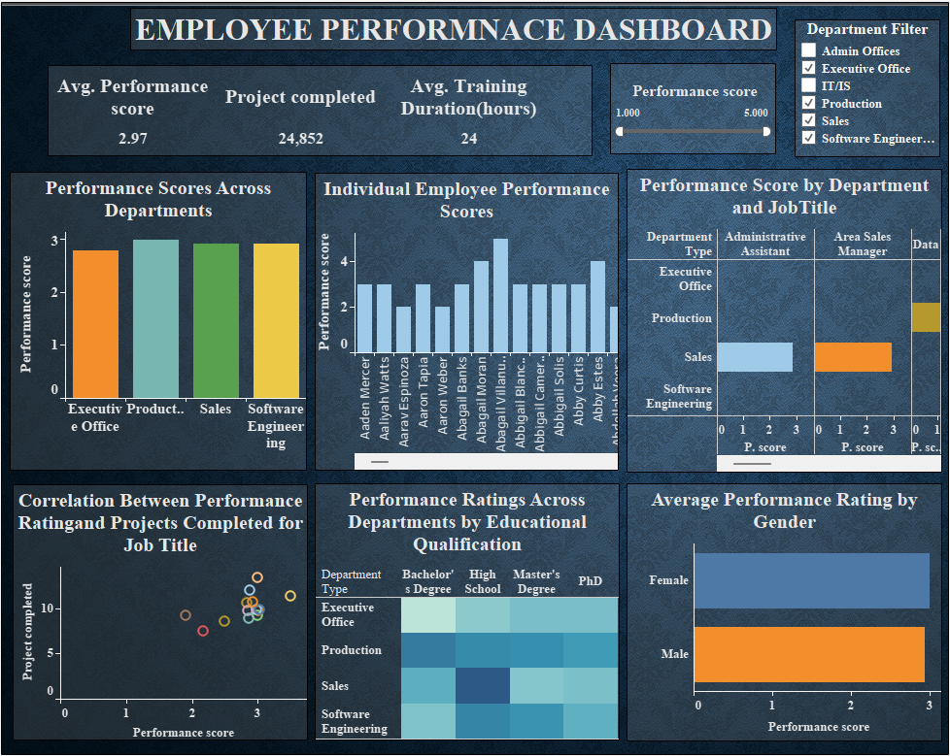

(figure 1.2) Interactive dashboard by Department Filter

The Employee Performance Dashboard utilizes a dynamic and interactive department filter, enabling users to customize the view based on selected departments such as Executive Office, Production, Sales, and Software Engineering. This feature allows for focused analysis, helping managers quickly identify performance trends and discrepancies within specific departments. By adjusting the filters, users can compare performance scores, project completion rates, and training hours across departments. The filter enhances the dashboard's utility by providing tailored insights, facilitating targeted interventions, and ensuring that high-performing areas are recognized. This interactive capability streamlines decision-making processes, making it easier to allocate resources effectively and address areas needing improvement.

**3.3 Dynamic and Interactive Employee Performance Dashboard Using Average Performance Filter:**

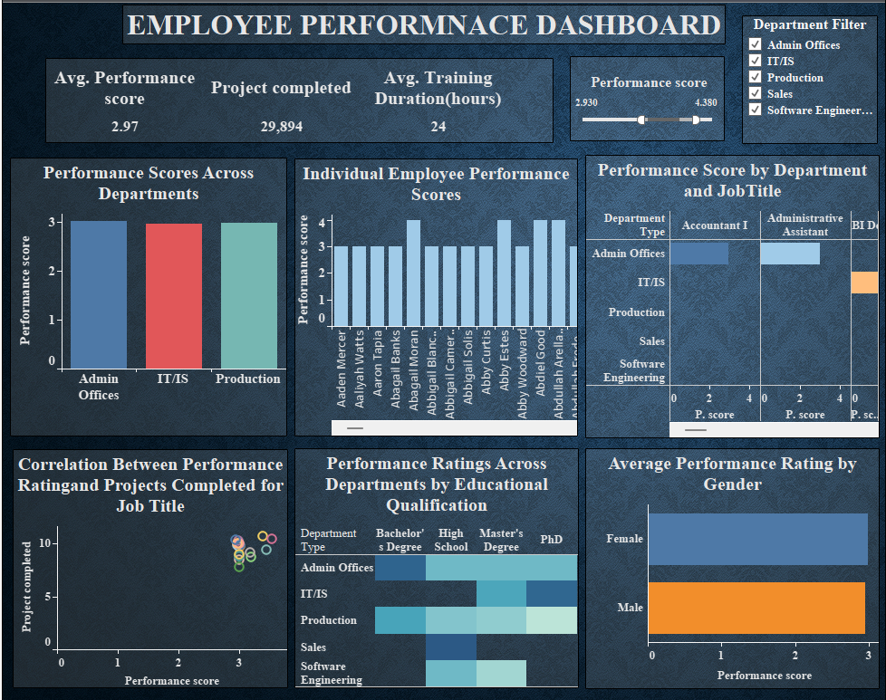

(figure 1.3) Interactive dashboard by Performance Score Filter

The Employee Performance Dashboard features a dynamic and interactive average performance filter, allowing users to adjust the range of performance scores displayed. This functionality helps focus on employees with specific performance levels, facilitating targeted analysis. By filtering the average performance scores, users can easily identify top performers and areas needing improvement across departments such as Admin Offices, IT/IS, and Production. The filter also impacts other visualizations, including individual performance scores, job title performance, and correlations between performance and project completion. This interactivity enhances decision-making by providing clear insights into employee performance metrics and trends, enabling more informed and effective management actions.

**3.4 Dynamic and Interactive Employee Performance Dashboard Using Average Performance Filter and Performance Score Filter:**

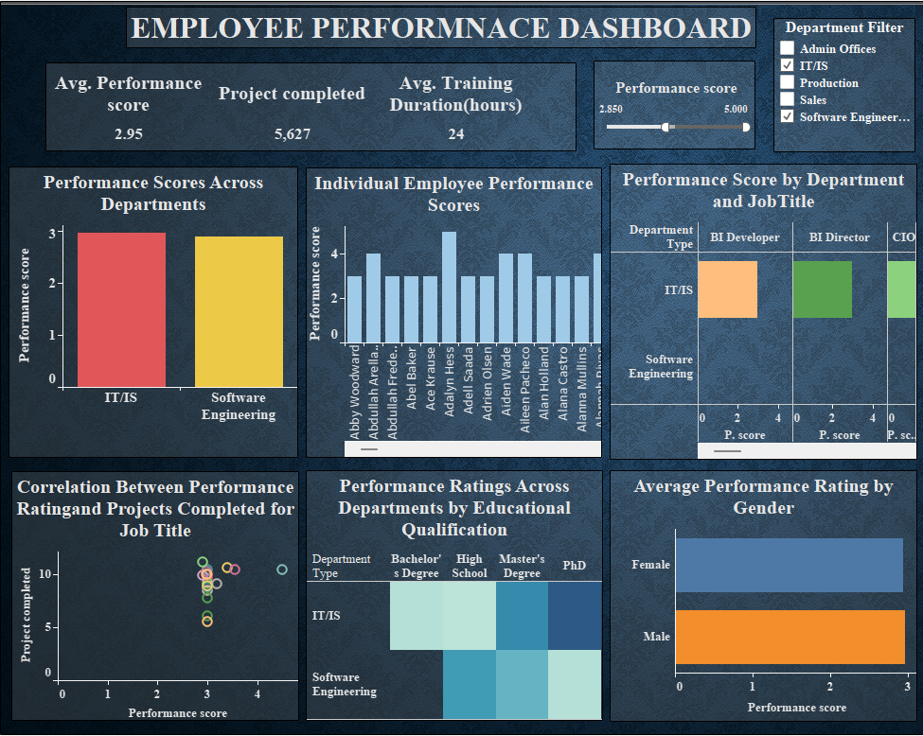

(figure 1.4) Interactive Dashboard using Filters

The Employee Performance Dashboard offers dynamic and interactive features, including an average performance filter and a department filter, to enhance data analysis. The average performance filter allows users to adjust the range of performance scores displayed, focusing on specific performance levels. This helps in identifying top performers and areas needing improvement. The department filter enables users to view performance metrics specific to selected departments such as IT/IS and Software Engineering. These filters impact various visualizations on the dashboard, including performance scores across departments, individual employee scores, and performance by job title. The combined use of these filters provides a comprehensive view of employee performance, aiding in targeted decision-making and management actions.

**CHAPTER 4**

**CONCLUSION AND FUTURE WORK**

**Conclusion:**

The Employee Performance Dashboard project successfully demonstrates the power and utility of data visualization in the domain of performance management. By integrating various performance-related data points and presenting them through interactive visualizations, the dashboard provides a comprehensive and user-friendly tool for managers to assess and enhance employee performance.

Through this project, we achieved several key objectives:

* **Data Consolidation:** We successfully imported and integrated employee performance data from multiple sources into Tableau, ensuring a cohesive and comprehensive dataset for analysis.
* **Effective Visualizations:** The creation of bar charts, scatter plots, and heatmaps allowed us to visualize performance scores by department and individual employees, analyze the relationship between performance scores and projects completed, and understand performance distribution across departments.
* **Interactive Dashboard:** The development of an interactive dashboard with dynamic filters enabled users to customize their analysis, facilitating deeper insights and more informed decision-making.
* **Key Performance Indicators:** The inclusion of KPIs such as average performance score, total projects completed, and training hours per employee provided a quick overview of organizational performance, helping to identify trends and areas for improvement.

**Future Work:**

To further enhance the Employee Performance Dashboard, several future improvements can be considered:

* **Advanced Analytics:** Integrate predictive analytics to forecast future performance trends and identify potential high performers.
* **Real-Time Data Integration:** Implement real-time data integration to provide up-to-date performance metrics and insights.
* **Customizable Metrics:** Allow users to define and customize additional performance metrics based on specific organizational needs.
* **Enhanced User Interface:** Improve the user interface for better usability and accessibility across different devices and platforms.
* **Employee Feedback Integration:** Incorporate employee feedback and satisfaction data to provide a more holistic view of performance and engagement.
* **Benchmarking:** Include benchmarking capabilities to compare performance against industry standards or competitors.
* **Training and Development Analysis:** Analyze the effectiveness of training programs on employee performance to identify areas for improvement and investment.